.bat file   
  
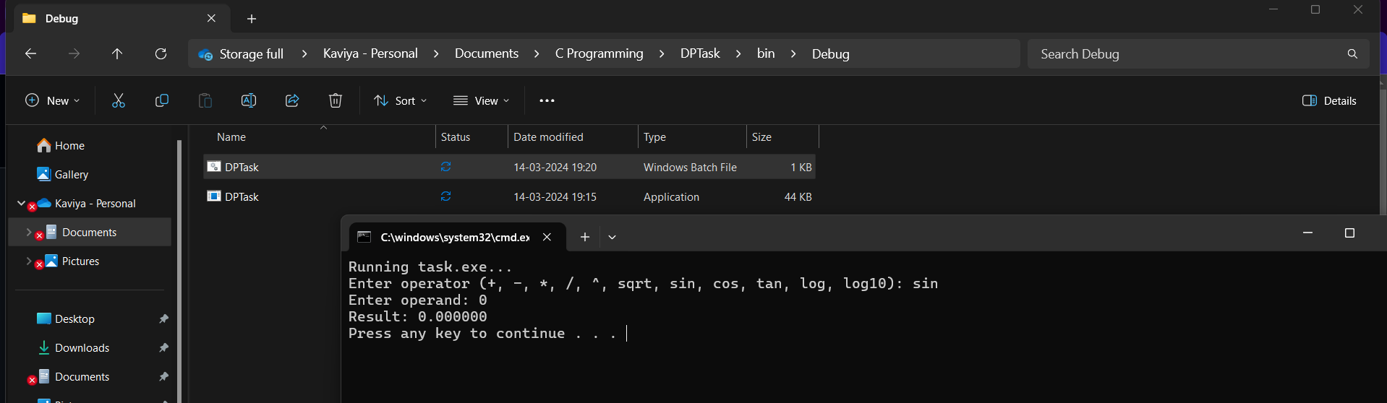  
  
  
.exe file   
  
